**Directions:** Using the four prompts below, identify how the FoodieLand app demonstrates good UX design.

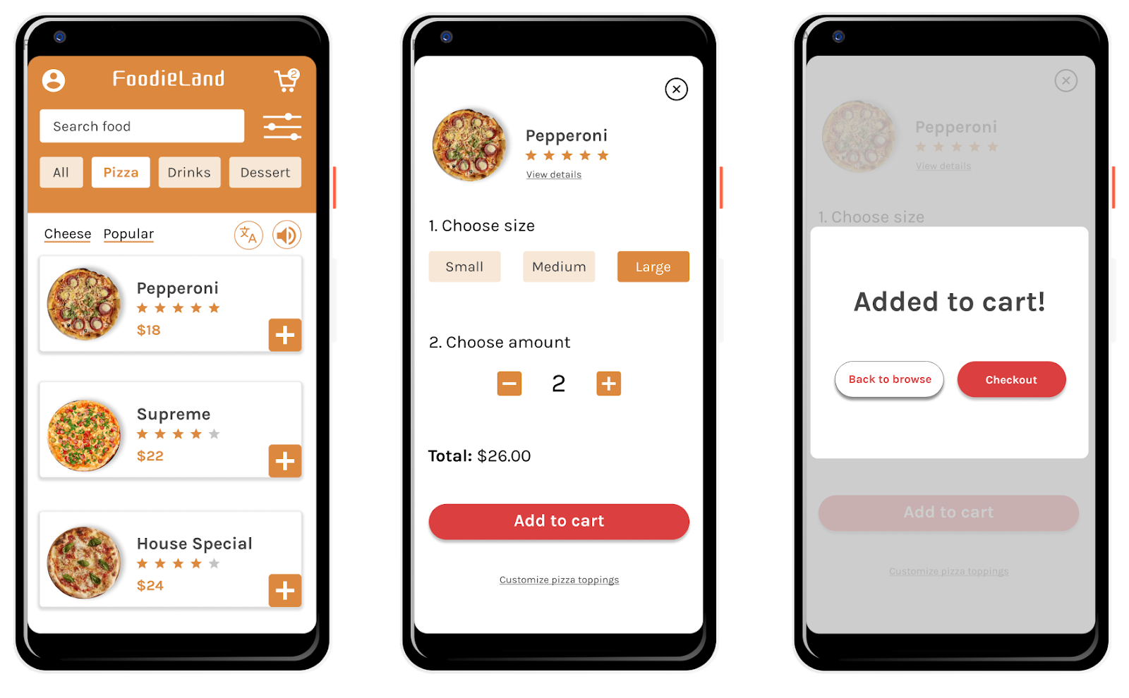

Prompt 1: Identify at least one aspect of the FoodieLand app that demonstrates usable design. Explain your reasoning in 1-2 sentences.

| Hint: Is the app’s design, structure, and purpose clear? Does the app have any elements or features that make it easy to navigate? | | |
| --- | --- | --- |

| **Usable** | The “Add to cart”, “Back to browse”, and “Checkout” buttons in the Foodieland app are examples of usable design because they clearly indicate what will happen next when users interact with them. |
| --- | --- |

## 

## Prompt 2: Identify at least one aspect of the FoodieLand app that demonstrates equitable design. Explain your reasoning in 1-2 sentences.

| Hint: Does the app address the needs of people with diverse abilities and backgrounds? | | |
| --- | --- | --- |

| **Equitable** | The Foodieland app’s translation feature is an example of equitable design because it is helpful for people who speak different languages. |
| --- | --- |

## 

## Prompt 3: Identify at least one aspect of the FoodieLand app that demonstrates enjoyable design. Explain your reasoning in 1-2 sentences.

| Hint: Does the app inspire a positive reaction from the user by considering their thoughts and feelings? Does the app engage users and make them excited to keep using the app? | | |
| --- | --- | --- |

| **Enjoyable** | The images used in the Foodieland app are examples of enjoyable design because they are visually appealing and help the user understand what they’re ordering. |
| --- | --- |

## Prompt 4: Identify at least one aspect of the FoodieLand app that demonstrates useful design. Explain your reasoning in 1-2 sentences.

| Hint: Does the app solve the problem of “how to help a busy person working from home select a meal to be delivered?” How does the app help solve this problem? | | |
| --- | --- | --- |

| **Useful** | The Foodieland app’s filter feature allows users to narrow down their search. This is an example of useful design because it helps the user easily select a pizza to order. |
| --- | --- |